**USING RAPTOR – CHECK GIVEN NUMBER PALINDROME OR NOT**

**T. SUMANTH**

**(192011452)**

**FLOWCHART**

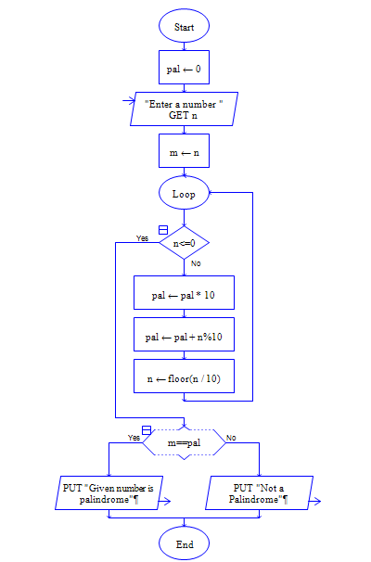

**OUTPUT**

INPUT IS 1234321

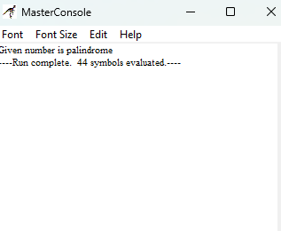

**RESULT:**

The program is executed and verified successfully